**SCENIC TRAIN RIDE**

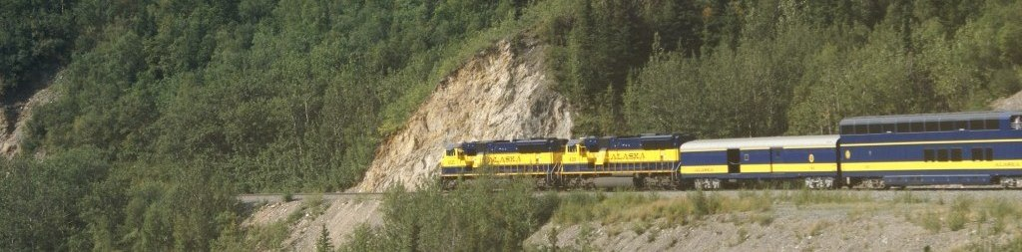

Wind your way through five hours of breathtaking mountainous scenery.

* $12.00 per rider
* Complimentary snacks

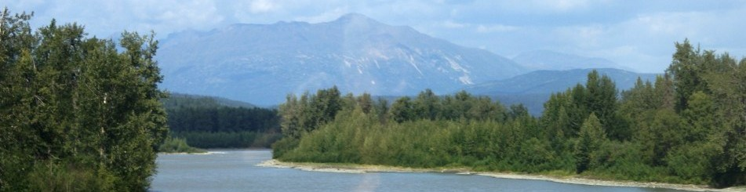

Call warner depot at 555-1283 for a ***ride to remember!***